

CA PPM v14.3

Benefits Calculation  
Release 1.1

# Version History

|  |  |  |  |
| --- | --- | --- | --- |
| Author | Date | Version | Comments |
| Alexandre Assis | 18/Sep/2015 | 1.0 | * Initial Draft |
| Alexandre Assis | 20/Apr/2016 | 1.1 | * New Demo Data with CA PPM ROI Study |

**Table of Contents**

1. Version History 2

2. Maintenance and Configuration 4

2.1. Implementing Benefits Management Accelerator 4

2.2. Preparing for a Proof-of-Concept 4

2.2.1. Creating a new Benefit Variable 4

2.2.2. Creating a new Benefit Calculation 7

2.2.3. Creating a new Benefit Group 9

# Maintenance and Configuration

## Implementing Benefits Management Accelerator

Implementing this Accelerator is very easy, provided you have all the pre-requisites. There are three basic steps:

1. Install the Accelerator
2. Create or Load your Benefit Data
3. Start using

There is only one pre-requisite:

1. You know how to calculate the Benefits for each project type

Final advice: before you start customizing, creating attributes, portlets and processes, implement this accelerator as-is. Once you start using it – you will be more qualified to realize what is missing and what is not working well for your company. Then you may plan to implement your changes (and please provide feedback so it may be incorporated in the future versions of the Accelerator).

## Preparing for a Proof-of-Concept

To use this in a POC you will need to understand the Project Types your customer uses and the Benefits they may obtain by executing that investment.

Each Investment will have its Formula and the Formula will need Variables.

You should create your Variables, then the Benefits Calculation, then the Benefit Groups.

In our example, a retail company will create a model for calculating the benefits of opening a new store.

Benefits of opening up a new:

* Additional Product Revenue;
  + Formula: # Units sold per year X Avg Product Unit Price

### Creating a new Benefit Variable

A Benefit Variable is one of the elements of a Benefit Calculation Formula.

In our Example, there are two variables:

#Units sold per Year

Avg Product Unit Price

To create a new Benefit Variable:

1. Navigate to “Benefits Calculation” then “Benefit Variables”.
2. Click “New Benefit Variable”.
3. Enter the name of the Benefit Variable and Save.

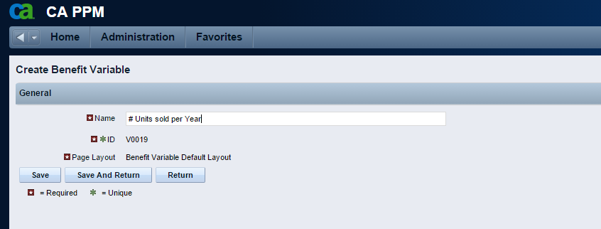

1. Fill the additional information and save.

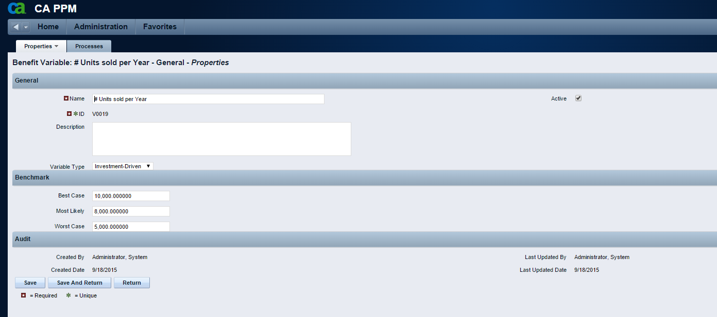

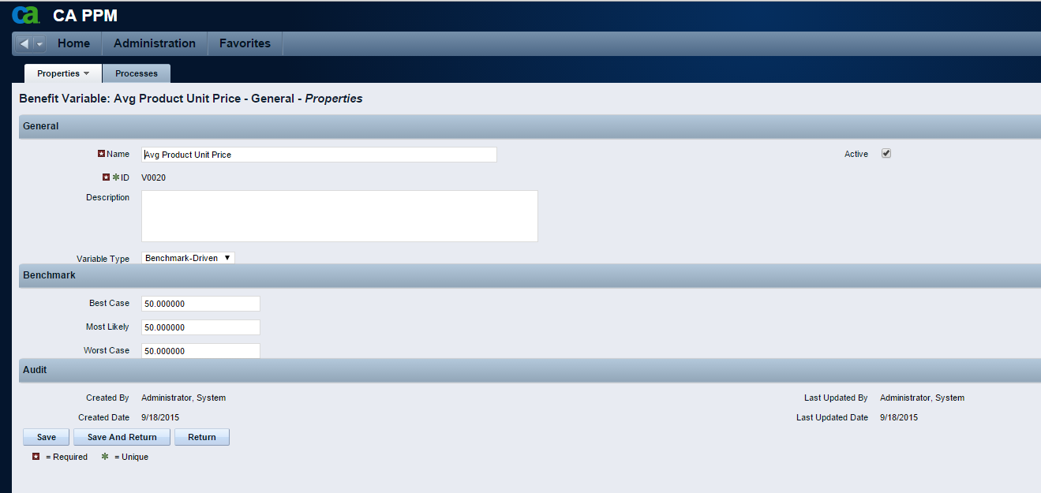

### Creating a new Benefit Calculation

Benefit Calculation refers to a specific Benefit that is calculated using your variables and a formula.

To create a new Benefit Calculation:

1. Navigate to “Benefits Calculation” then “Benefits Calculations”.
2. Click “New Benefit Calculation”.
3. Enter the name of the Benefit Calculation and Save.

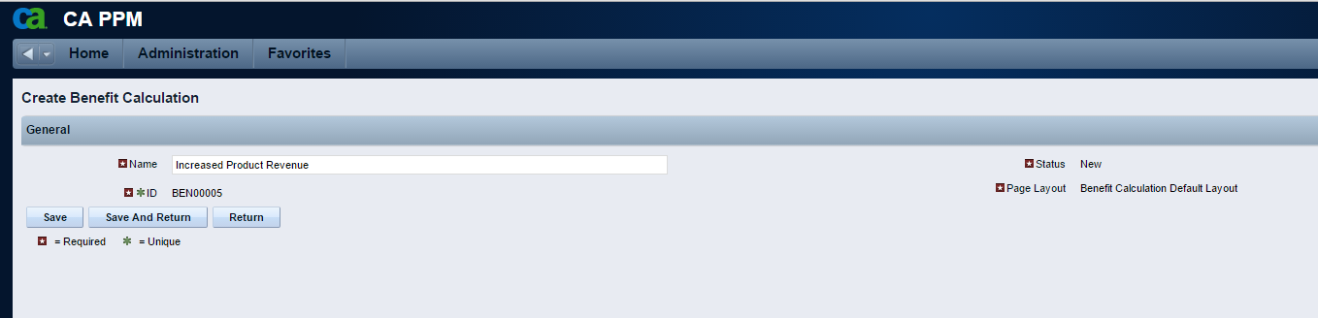

1. Enter the additional attributes and Save. The formula should contain only the Variables you specify on the Benefit Variables attribute.

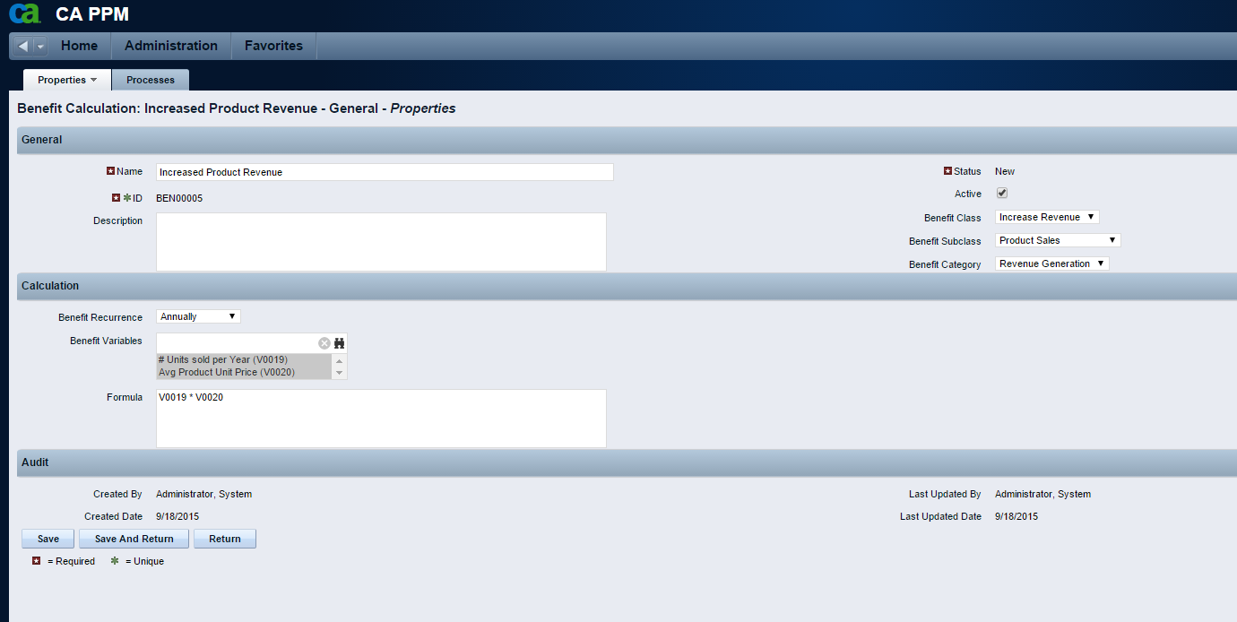

### Creating a new Benefit Group

A Benefit Group corresponds to a group of Benefits that are achieved by executing an Investment of a specific Type.

To create a new Benefit Group:

1. Navigate to “Benefits Calculation” then “Benefit Groups”.
2. Click “New Benefit Group”.
3. Enter the Name of the Benefit Group, then click Save.

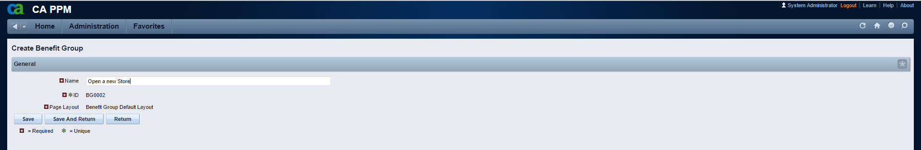

1. Associate the Benefit Calculations with your Benefit Group and Save.

